1. How to handle ‘Text Boxes’ in Selenium WebDriver

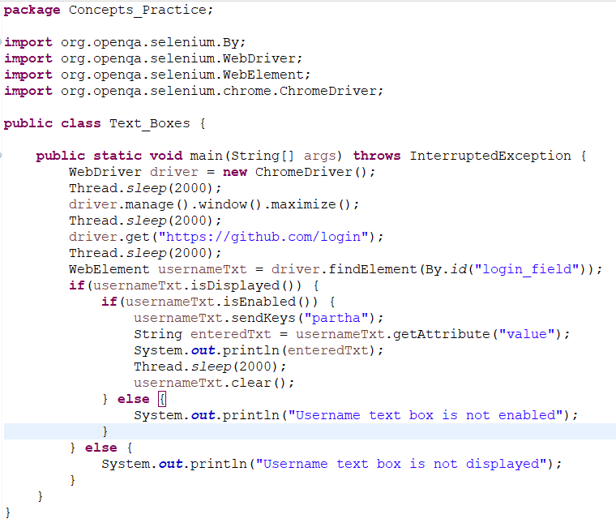

1. How to handle ‘Basic HTML Controls’ in Selenium WebDriver

There are 6 types of ‘Basic HTML Controls’.

* Text boxes
* Links
* Buttons
* Radio buttons
* Check boxes
* Drop downs

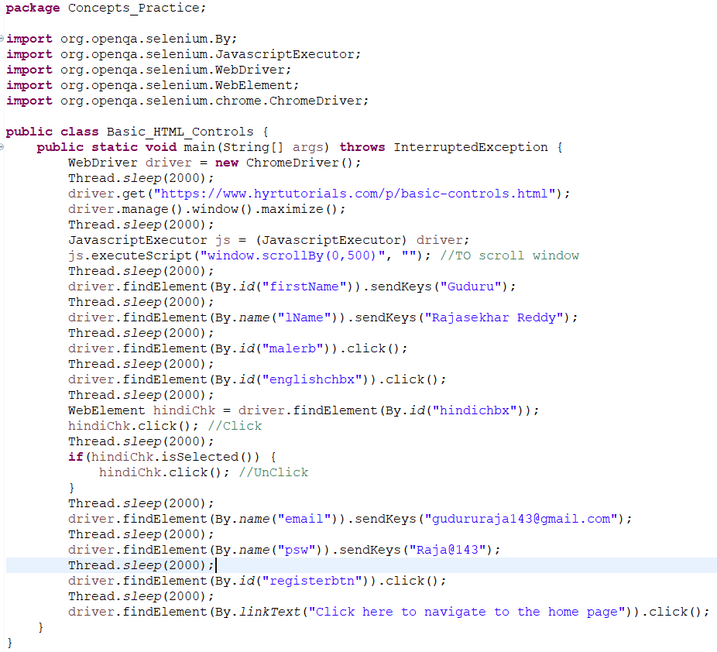

1. How to handle ‘Drop Downs’ in Selenium WebDriver

There are two types of drop downs.

* Single Selection Drop down.

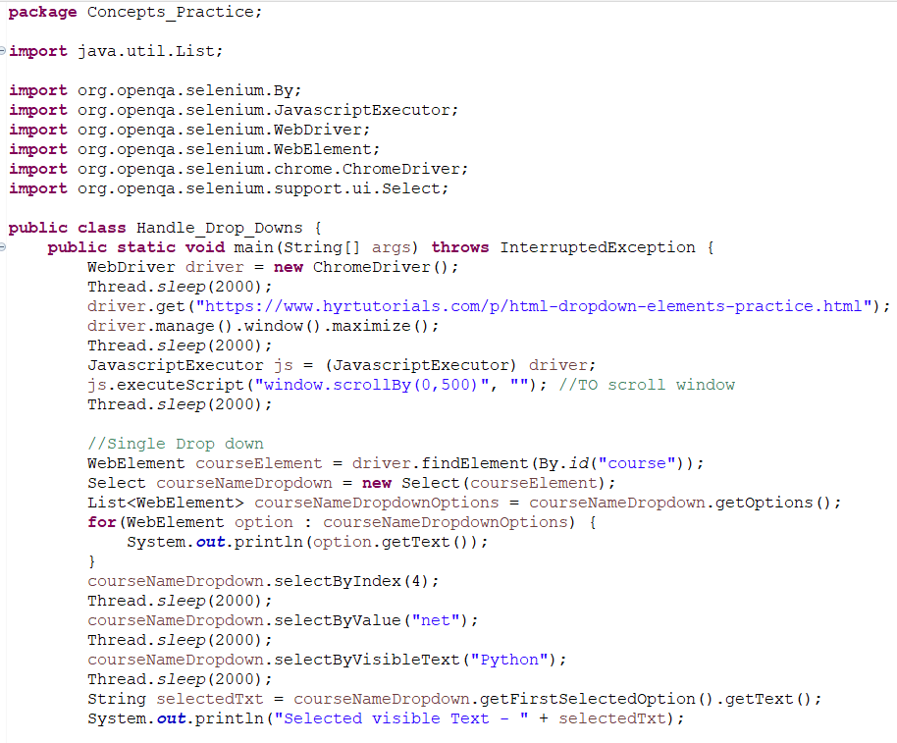

* Multi Selection Drop down

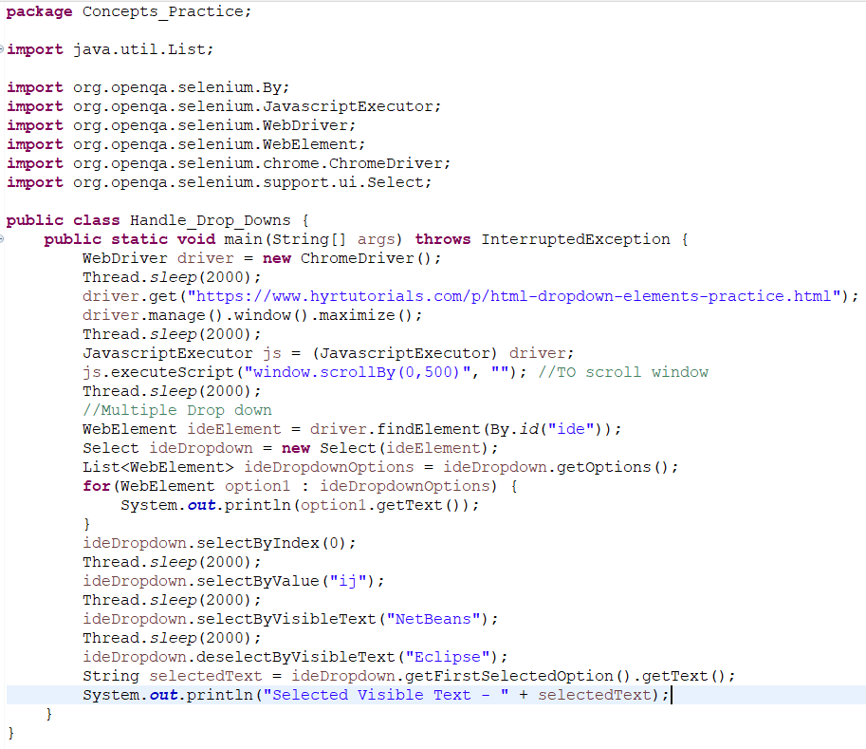

* Printing the selected values after deselecting –



1. Navigation Methods in Selenium WebDriver

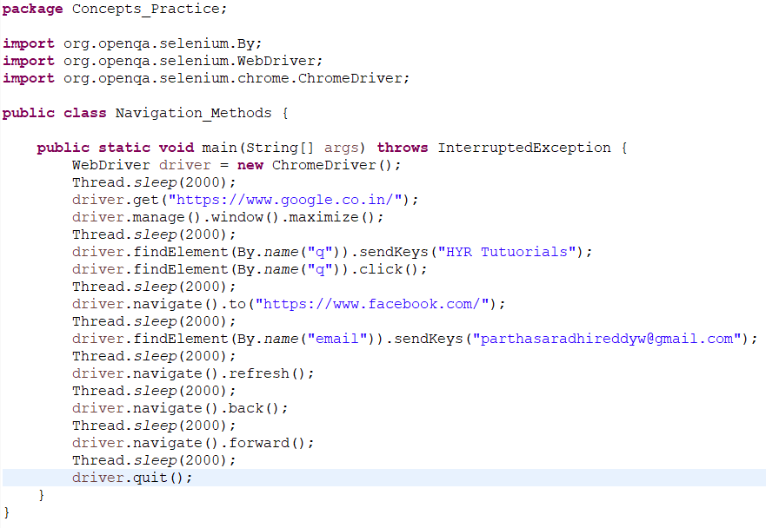

1. How to handle Alerts in Web page in Selenium WebDriver

We can select any element in Alerts by three ways.

* Select by Value
* Select by Index
* Select by Visible Text

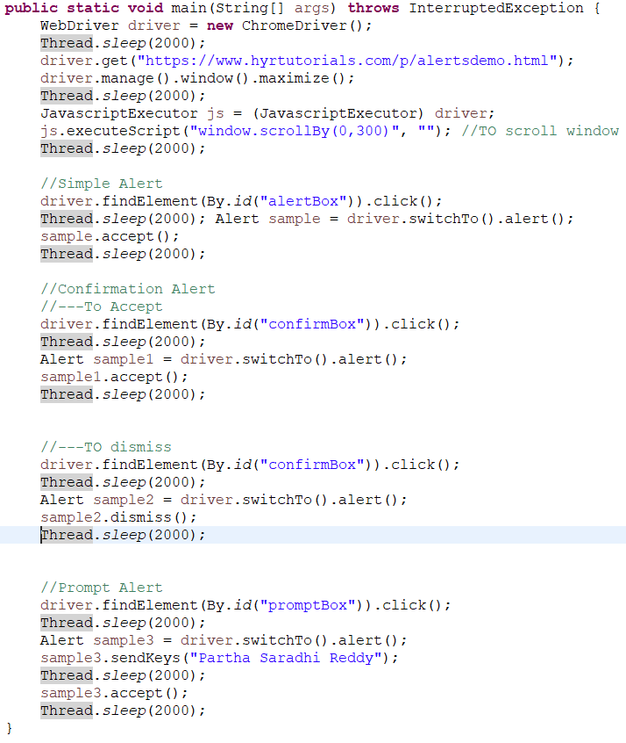

1. How to handle Multiple Windows in Selenium WebDriver

To handle windows, there are two ways.

* getwindowHandle()

It will return the current focused window handle.

* getwindowHandles()

It will return both two window handles.

Set not allows duplicate but allows only unique values.

List allows duplicate values.

To store all the unique values, we need a set.

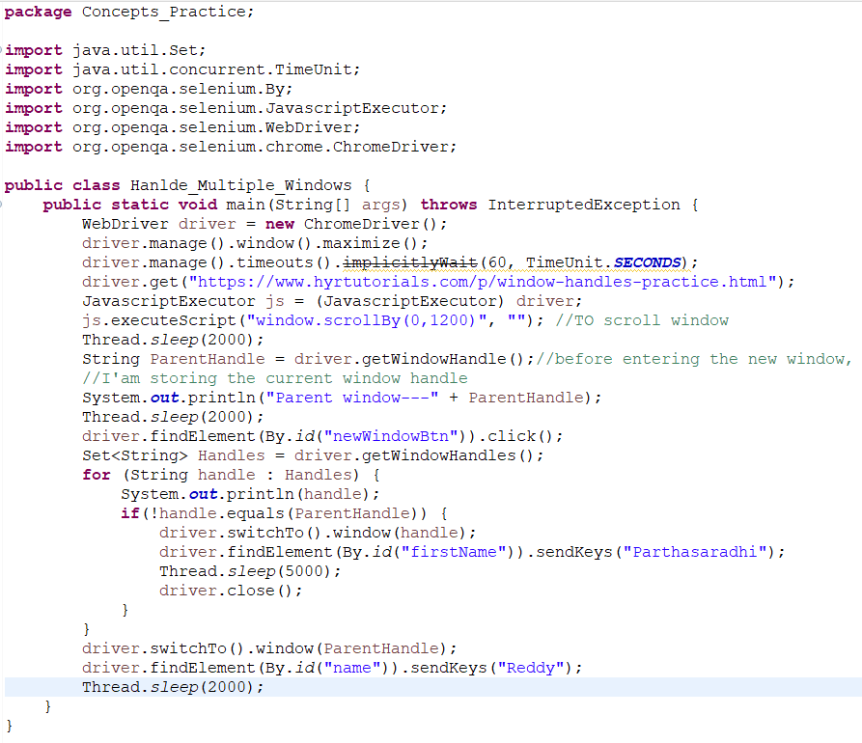

1. How to handle frames in a web page using Selenium WebDriver.

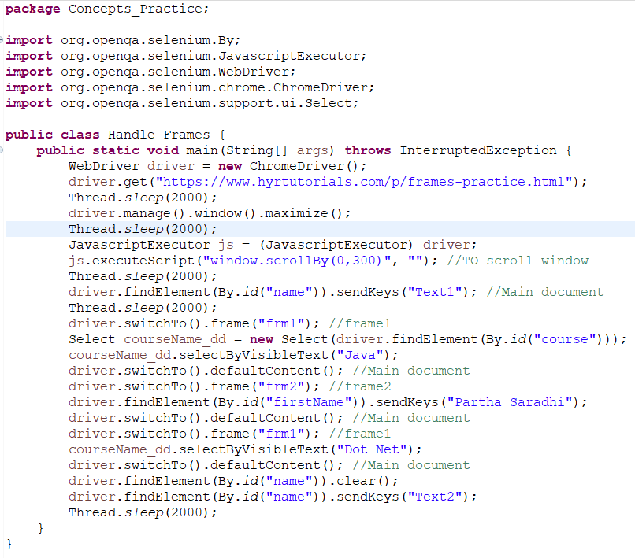

1. How to capture a screenshot of a webpage using Selenium WebDriver

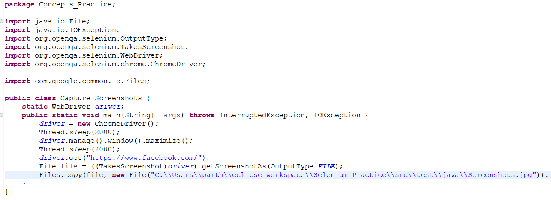

1. How to maximize browser window in Selenium WebDriver

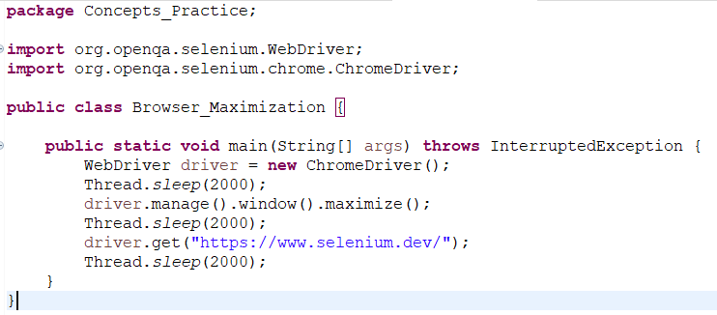

1. How to get URL, Title and Page Source using Selenium WebDriver

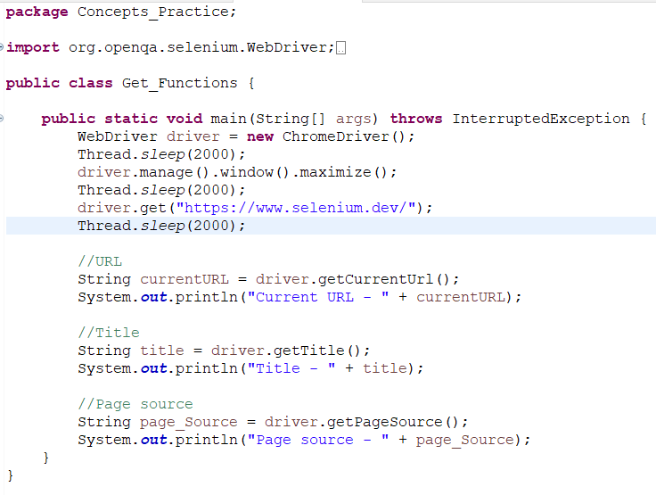

1. PageLoadTimeOut in Selenium WebDriver

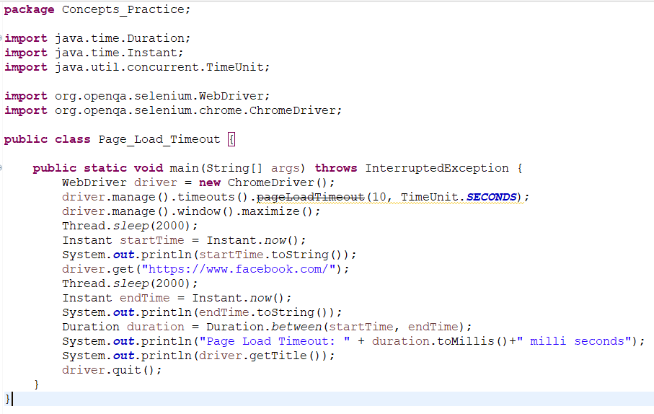

1. Implicit Wait in Selenium WebDriver

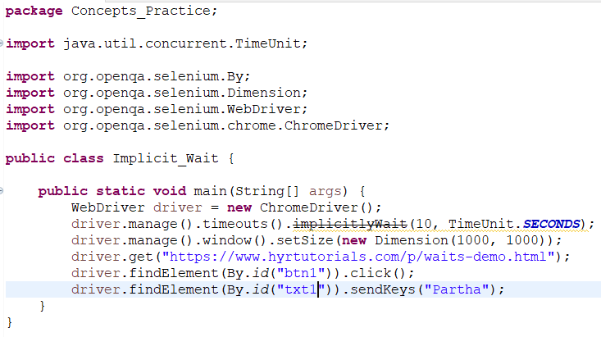

1. Explicit Wait in Selenium WebDriver

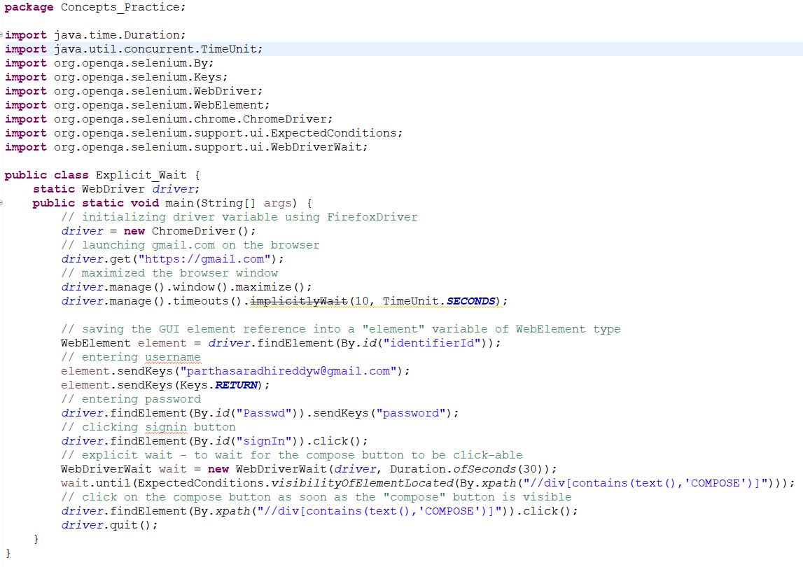

1. Mouse Actions in Selenium WebDriver

There are four types of Mouse Actions in Selenium WebDriver.

* Mouse hover / Move to element
* Click
* Double click
* Right click / Context click

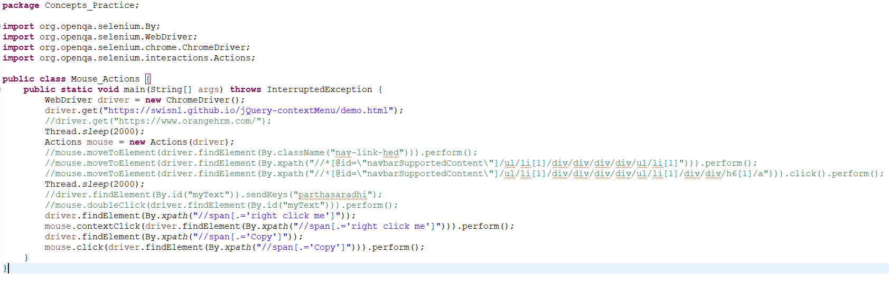

1. How to get WebElement properties in Selenium WebDriver

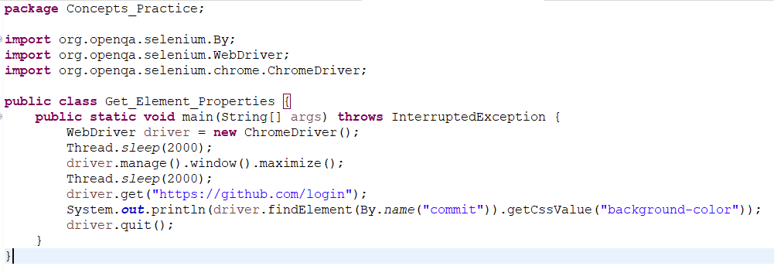

1. How to handle Calendars in Selenium WebDriver

* Calendar – 1

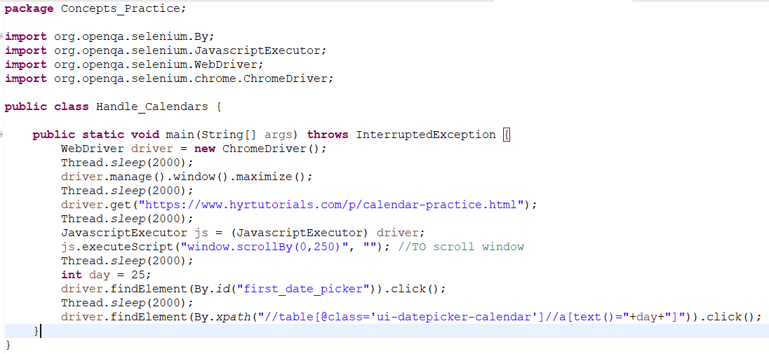

* Calendar – 2



* Calendar – 3

